DAYANANDA SAGAR COLLEGE OF ENGINEERING
(An Autonomous Institute affiliated to VTU, Belagavi, Approved by AICTE & ISO 9001:2008 Certified)
Accredited by National Assessment & Accreditation Council (NAAC) with ‘A’ grade,
Shavige Malleshwara Hills, Kumaraswamy Layout, Bengaluru-111


Report
On
“ SMART CAMPUS INFORMATION SYSTEM APPLICATION”
Submitted by
SABEEH AHMAD (1DS25CS219)
SAMRUDH MAHESH KONI (1DS25CS229)

First Semester B.E (CSE)
2025-2026

Under the guidance of
Dr. Rohini T.V
Professor
Dept. of CSE
DSCE, Bangalore

Department of Computer Science and Engineering
Bangalore-780111

VISVESVARAYA TECHNOLOGICAL UNIVERSITY
DAYANANDA SAGAR COLLEGE OF ENGINEERING
Shavige Malleshwara Hills, Kumaraswamy Layout, Bangalore - 560111
Department of Computer Science & Engineering


CERTIFICATE

This is to certify that the application entitled “SMART CAMPUS INFORMATION SYSTEM APPLICATION” is a bonafide work carried out by SABEEH AHMAD [1DS25CS219] & SAMRUDH MAHESH KONI (1DS25CS229) during the Second Semester Python Programming Laboratory Sessions, Bachelor of Engineering in Computer Science and Engineering under Visvesvaraya Technological University, Belgaum in the academic year 2025–26.

Faculty In-charge Name Dr.Ramesh Babu
(Faculty In-charge) Vice principal & Head
Designation, Department of CSE,
Department of CSE, DSCE
DSCE
Signature.................... Signature....................

Name of the Examiners: Signature with date:
- .................................... ………………………………

- .................................... ……………………………….

Application – Smart Campus Information System
Dayananda Sagar College of Engineering plans to develop a simple Python-based Smart Campus Information System to manage student information, academic records, and performance analysis. At present, several administrative tasks such as student registration, course enrollment, record maintenance, searching student data, fee calculation, and performance analysis are often handled manually. These manual processes can be time-consuming, inefficient, and prone to errors.
To improve efficiency and accuracy, the institution intends to implement a basic software system that enables administrative staff to perform various academic management tasks digitally. The system will allow administrators to register students, manage course enrollments, maintain academic records, search and sort student data, calculate fees, store and retrieve records from files, scan directories for project files, and analyze student performance using data analytics tools.
The Smart Campus Information System will be developed gradually through Python laboratory experiments. Each experiment focuses on implementing a specific functional module, and together these modules form a complete integrated application. The final system will consist of several modules such as Student Registration, Course Enrollment Management, Student Records Management, Search and Sorting, Fee Calculation, File Management, Directory Scanning, and Performance Analytics, all integrated through a Main System Application Dashboard.
Students will develop these modules week by week, and in the final weeks they will integrate all modules to demonstrate the complete working of the Smart Campus Information System.

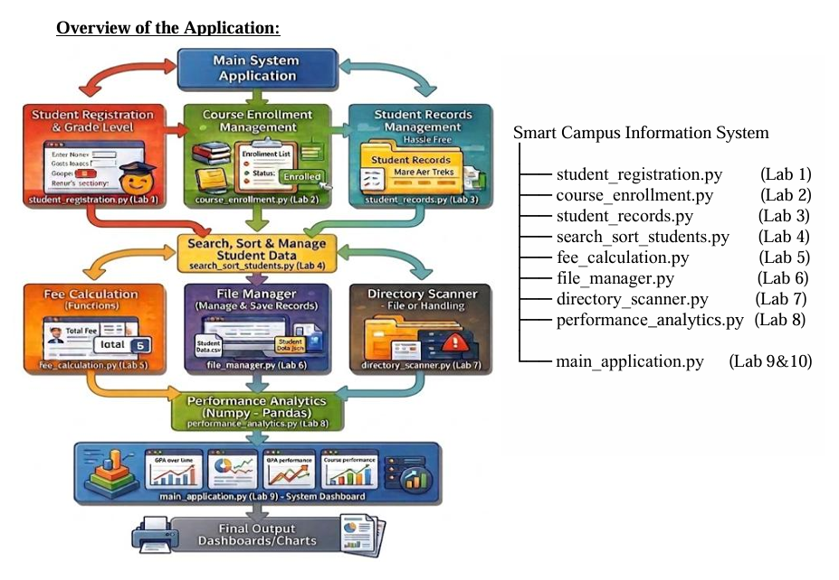

Smart Campus Information System (Mini Project Integration) : Demonstrate a complete Python application for the Smart Campus Information System by integrating all the modules developed from Lab 1 to Lab 8.
The final program should demonstrate the working of all components including:
- Student registration and grade evaluation
- Course enrollment management
- Student record storage and management
- Searching and sorting student data
- Fee calculation using functions
- File-based academic record management
- Directory scanning with exception handling
- Student performance analytics using NumPy, Pandas, and Matplotlib

CONTENTS

1. Abstract
2. Technologies Used
3. Introduction
4. Methodology
5. Results
6. Conclusion
7. References

ABSTRACT

The Smart Campus Information System is a Python-based mini project developed to simplify routine academic administration tasks such as student registration, course enrollment, academic record maintenance, searching and sorting of student data, fee calculation, file storage, directory scanning, and performance analysis.

The application integrates all laboratory programs into a single menu-driven console system. It reduces manual work, improves accuracy, and demonstrates how fundamental Python concepts such as conditional statements, loops, functions, lists, dictionaries, sets, file handling, exception handling, and data analytics libraries can be combined to solve a real campus management problem.

TECHNOLOGIES USED

1. Python 3 for application development.
2. Built-in modules: csv and os.
3. Data structures: lists, dictionaries, tuples, and sets.
4. Functional concepts: user-defined functions and modular programming.
5. Exception handling for invalid paths and empty folders.
6. NumPy for numerical analysis.
7. Pandas for tabular data processing.
8. Matplotlib for chart generation and performance visualization.

INTRODUCTION

Educational institutions manage a large amount of student-related information every day. When registration, course allocation, records, and performance tracking are handled manually, the process becomes slow and error-prone. A simple software-based system can organize this information more effectively and help administrative staff work with better accuracy.

The Smart Campus Information System was designed as an integrated laboratory application to address these needs. It combines the concepts learned in Python Programming Laboratory and presents them through a single dashboard. The project shows how Python can be used not only for basic programs but also for building a practical academic support application.

METHODOLOGY

The development of the Smart Campus Information System followed a modular approach. Each lab program was first implemented as an individual feature and later integrated into one consolidated system.

1. Student Registration and Grade Evaluation: The program accepts student details such as name, age, and marks. Conditional statements are used to assign grades and performance remarks.
2. Course Enrollment Management: A loop-based module allows the administrator to add up to five courses for a student. Invalid entries are skipped using validation and control statements.
3. Student Records Management: Student details are stored using a list of dictionaries. This helps in managing multiple records in a structured way.
4. Event Participation Analysis: Sets are used to compare students participating in different campus events and to identify common and unique participants.
5. Sorting and Searching: Student IDs are arranged using Bubble Sort and Selection Sort. Linear Search and Binary Search are used to locate a required ID efficiently.
6. Fee Calculation: User-defined functions are used to compute tuition, hostel, and transportation charges and generate the total fee for each student.
7. File Handling: Student academic records are written to and read from a CSV file. The stored data is processed to calculate average marks and identify the top-performing student.
8. Directory Scanning: The os module and exception handling are used to display folder structures and handle missing directories or empty folders safely.
9. Performance Analytics: NumPy, Pandas, and Matplotlib are used to analyze subject-wise marks and generate charts for performance comparison.
10. Main Dashboard Integration: All modules are connected through a single menu-driven application so that the user can access every feature from one interface.

RESULTS

The final integrated application was implemented successfully as a Python console program named "smart_campus.py". The system allows the user to register students, evaluate grades, enroll courses, display records, analyze event participation, sort and search student IDs, calculate fees, manage academic record files, scan directories, and perform performance analytics.

During testing, the program compiled successfully and the menu-driven flow worked as intended. The analytics module produces subject-wise summaries and saves graphical output files such as "average_scores.png" and "student_performance_comparison.png".

The result demonstrates that all individual lab exercises can be integrated into one practical mini project. The application is suitable as a draft academic prototype for smart campus data handling.

Suggested additions for the final submission: insert screenshots of program execution, add actual student details on the cover page, and update faculty information and examiner signatures.

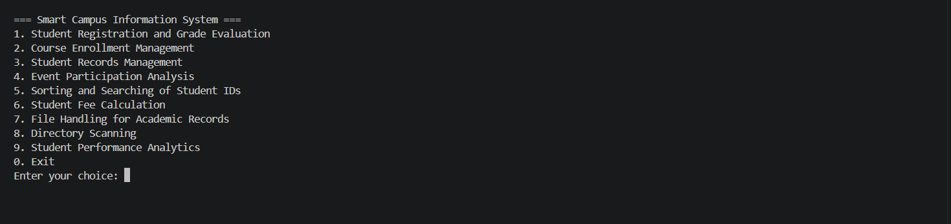
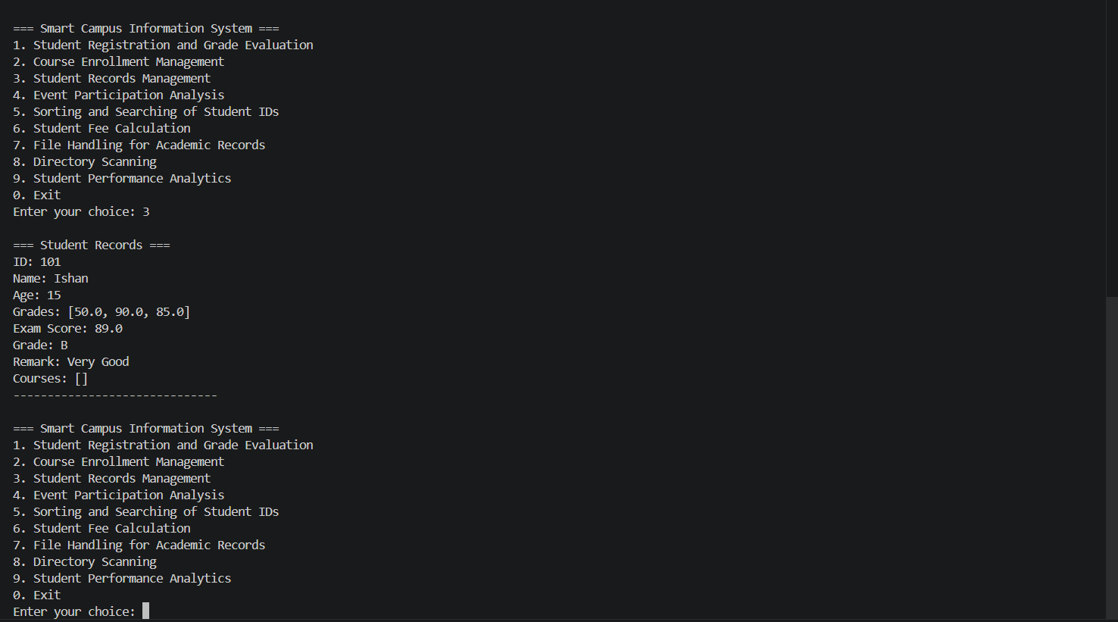

CONCLUSION

The Smart Campus Information System successfully brings together the important programming concepts covered in the Python laboratory. It shows how a problem can be broken into smaller modules and then integrated into a complete working application.

The project improves the efficiency of handling academic data and provides a clear demonstration of core Python skills including decision making, looping, data structures, functions, file handling, exception handling, and data analytics. With additional user interface enhancements and database integration, the same system can be extended into a more advanced campus management solution.

REFERENCES

1. Python Programming Laboratory Manual, Dayananda Sagar College of Engineering.
2. Python Software Foundation. Python 3 Documentation. https://docs.python.org/3/
3. NumPy Documentation. https://numpy.org/doc/
4. Pandas Documentation. https://pandas.pydata.org/docs/
5. Matplotlib Documentation. https://matplotlib.org/stable/users/index.html

